Maharishi Vidya Mandir Prayagraj
(Allahabad)

A Project Report
on

Carrer Objective

For
AISSCE 2019 Examination
[As a part of the Informatics Practices Course (065 new)]

SUBMITTED BY
…………..
[Roll No…….]

Under the Guidance of:
…………….
PGT (Comp.Sc)
CERTIFICATE

This is to certify that the Project / Dissertation entitled Carrer Objective is a bonafide work done by Master Yash Srivastava of class XII Session 2019-20 in partial fulfillment of CBSE’s AISSCE Examination 2019 and has been carried out under my direct supervision and guidance. This report or a similar report on the topic has not been submitted for any other examination and does not form a part of any other course undergone by the candidate.

………………………… ……………………………..

Signature of Principal Signature of Teacher/Guide

Name: ……….......................
Designation: PGT (Comp.Sc

Place:…………….

Date:……………..

ACKNOWLEDGEMENT
Iundertook this Project work, as the part of my XII-Informatics Practices course. I had tried to apply my best of knowledge and experience, gained during the study and class work experience. However, developing software system is generally a quite complex. It requires a systematic study, insight vision and professional approach during the design and development. Moreover, the developer always feels the need, the help and good wishes of the people near you, who have considerable experience and idea.
I would like to extend my sincere thanks and gratitude to my teacher Ms. Prity Ma’am. I am very much thankful to our Principal Ms.Pooja chandola ma’am for giving valuable time and moral support to develop this software.
I also feel indebted to my friends for the valuable suggestions during the project work.

Yash Srivastava

Class XII.

(Science)

C O N T E N T S

1. Introduction 5
2. Theoretical Background 6
3. System Implementation 9
3.1 The Hardware used: 9
3.2 The Softwares used: 9
4. System Design & Development 10
4.1 Database Design: 10
4.2 Menu Design: 10
5. References

1. Introduction
This software project is developed to automate the functionalities of a Public Library.The purpose of the software project is to develop the Management Information System (MIS) to automate the record keeping of Publishers, Books, Members and Book issue and receive transactions with a view to enhance the decision making of the functionaries.
A MIS mainly consists of a computerized database, a collection of inter-related tables for a particular subject or purpose, capable to produce different reports relevant to the user. An application program is tied with the database for easy access and interface to the database. Using Application program or front-end, we can store, retrieve and manage all information in proper way.
This software, being simple in design and working, does not require much of training to users, and can be used as a powerful tool for automating a Public Library System.
During coding and design of the software Project, Java NetBeans IDE, a powerful front-end tool is used for getting Graphical User Interface (GUI) based integrated platform and coding simplicity. As a back-end a powerful, open source RDBMS, My SQL is used as per requirement of the CBSE curriculum of Informatics Practices Course.

2. Theoretical Background

2.1 What is Database?

Introduction and Concepts:
A database is a collection of information related to a particular subject or purpose, such as tracking customer orders or maintaining a music collection. Using any RDBMS application software like MS SQL Server, MySQL, Oracle, Sybase etc, you can manage all your information from a single database file. Within the file, divide your data into separate storage containers called tables. You may and retrieve the data using queries.
A table is a collection of data about a specific topic, such as products or suppliers. Using a separate table for each topic means you can store that data only once, which makes your database more efficient and reduces data-entry errors. Table organises data into columns (called fields) and rows (called records).
A Primary key is one or more fields whose value or values uniquely identify each record in a table. In a relationship, a primary key is used to refer to specific record in one table from another table. A primary key is called foreign key when it is referred to from another table.

To find and retrieve just the data that meets conditions you specify, including data from multiple tables, create a query. A query can also update or delete multiple records at the same time, and perform built-in or custom calculations on your data.

Role of RDBMS Application Program:
A computer database works as a electronic filing system, which has a large number of ways of cross-referencing, and this allows the user many different ways in which to re-organize and retrieve data. A database can handle business inventory, accounting and filing and use the information in its files to prepare summaries, estimates and other reports. The management of data in a database system is done by means of a general-purpose software package called a Database Management System (DBMS). Some commercially available DBMS are MS SQL Server, MS ACCESS, INGRES, ORACLE, and Sybase. A database management system, therefore, is a combination of hardware and software that can be used to set up and monitor a database, and can manage the updating and retrieval of database that has been stored in it. Most of the database management systems have the following capabilities:
- Creating of a table, addition, deletion, modification of records.
- Retrieving data collectively or selectively.
- The data stored can be sorted or indexed at the user's discretion and direction.
- Various reports can be produced from the system. These may be either standardized report or that may be specifically generated according to specific user definition.
- Mathematical functions can be performed and the data stored in the database can be manipulated with these functions to perform the desired calculations.
- To maintain data integrity and database use.
The DBMS interprets and processes users' requests to retrieve information from a database. In most cases, a query request will have to penetrate several layers of software in the DBMS and operating system before the physical database can be accessed. The DBMS responds to a query by invoking the appropriate subprograms, each of which performs its special function to interpret the query, or to locate the desired data in the database and present it in the desired order.

2.2 What is My SQL ?
The management of data in a database system is done by means of a general-purpose software package called a Database Management System (DBMS). Some commercially available RDBMS are MS SQL Server, MS ACCESS, INGRES, ORACLE, and Sybase.
MySQL, the most popular Open Source SQL database management system, is developed, distributed, and supported by Oracle Corporation. MySQL is named after co-founder Monty Widenius's daughter, My. The name of the MySQL Dolphin (our logo) is “Sakila,”.
- MySQL is a database management system.
A database is a structured collection of data. It may be anything from a simple shopping list to a picture gallery or the vast amounts of information in a corporate network. To add, access, and process data stored in a computer database, you need a database management system such as MySQL Server. Since computers are very good at handling large amounts of data, database management systems play a central role in computing, as standalone utilities, or as parts of other applications.
- MySQL is based on SQL.
A relational database stores data in separate tables rather than putting all the data in one big storeroom. This adds speed and flexibility. The SQL part of “MySQL” stands for “Structured Query Language.” SQL is the most common standardized language used to access databases and is defined by the ANSI/ISO SQL Standard. The SQL standard has been evolving since 1986 and several versions exist. In this manual, “SQL-92” refers to the standard released in 1992, “SQL:1999” refers to the standard released in 1999, and “SQL:2003” refers to the current version of the standard.
- MySQL software is Open Source.
Open Source means that it is possible for anyone to use and modify the software. Anybody can download the MySQL software from the Internet and use it without paying anything. If you wish, you may study the source code and change it to suit your needs. The MySQL software uses the GPL (GNU General Public License),
- The MySQL Database Server is very fast, reliable, and easy to use.
If that is what you are looking for, you should give it a try. MySQL Server also has a practical set of features developed in close cooperation with our users. You can find a performance comparison of MySQL Server with other database managers on our benchmark page. MySQL Server was originally developed to handle large databases much faster than existing solutions and has been successfully used in highly demanding production environments for several years. Although under constant development, MySQL Server today offers a rich and useful set of functions. Its connectivity, speed, and security make MySQL Server highly suited for accessing databases on the Internet.
- MySQL Server works in client/server or embedded systems.
The MySQL Database Software is a client/server system that consists of a multi-threaded SQL server that supports different backends, several different client programs and libraries, administrative tools, and a wide range of application programming interfaces (APIs).

The Main Features of MySQL
- Written in C and C++.
- Works on many different platforms.
- Uses multi-layered server design with independent modules.
- Provides transactional and nontransactional storage engines.
- Designed to make it relatively easy to add other storage engines. This is useful if you want to provide an SQL interface for an in-house database.
- Uses a very fast thread-based memory allocation system.
- Executes very fast joins using an optimized nested-loop join.
- Implements SQL functions using a highly optimized class library that should be as fast as possible. Usually there is no memory allocation at all after query initialization.
- Provides the server as a separate program for use in a client/server networked environment, and as a library that can be embedded (linked) into standalone applications. Such applications can be used in isolation or in environments where no network is available.
- Password security by encryption of all password traffic when you connect to a server.
- Support for large databases. We use MySQL Server with databases that contain 50 million records. We also know of users who use MySQL Server with 200,000 tables and about 5,000,000,000 rows.
- MySQL client programs can be written in many languages. A client library written in C is available for clients written in C or C++, or for any language that provides C bindings.
- APIs for C, C++, Eiffel, Java, Perl, PHP, Python, Ruby, and Tcl are available, enabling MySQL clients to be written in many languages.
- The Connector/ODBC (MyODBC) interface provides MySQL support for client programs that use ODBC (Open Database Connectivity) connections.
- The Connector/J interface provides MySQL support for Java client programs that use JDBC connections. Clients can be run on Windows or Unix. Connector/J source is available.

2.3 What is Python?
Python is a open source programming language . Which was developed by in early 1990s. It is a high level programming language which supports in build modules which can be directly implemented and can be used at specfic position, it is easier than other programming language just like java, C and C++ . Now a days it is also used in many ir fields to make or hack some of the sites it usually comes under python 3.

2.4Features of Python

3. System Implementation

3.1 The Hardware used:

While developing the system, the used hardware are:
Intel(R) Core(TM) i3 CPU M 380 @ 2.53 GHz processor having 1.87 GB RAM.

3.2 The Softwares used:
- Microsoft windows 7 Operating System.
- Python Front-end Development environment.
- MySQL as Back-end Sever with Database for Testing.
- MS-Word 2007 for documentation.

4. System Design & Development

4.1 Database Design:
An important aspect of system design is the design of data storage structure. To begin with a logical model of data structure is developed first. A database is a container object which contains tables, queries, reports and data validation policies enforcement rules or contraints etc. A logical data often represented as a records are kept in different tables after reducing anomalies and redundancies. The goodness of data base design lies in the table structure and its relationship.
This software project maintains a database named “Carrer_objective” which contains the following tables.

Table Design:
The database of Library System contains 7 tables. The tables are normalized to minimize the redundancies of data and enforcing the validation rules of the organization. Most of the tables are designed to store master records. The tables and their structure are given below.

Table 1 :- carreaobjective
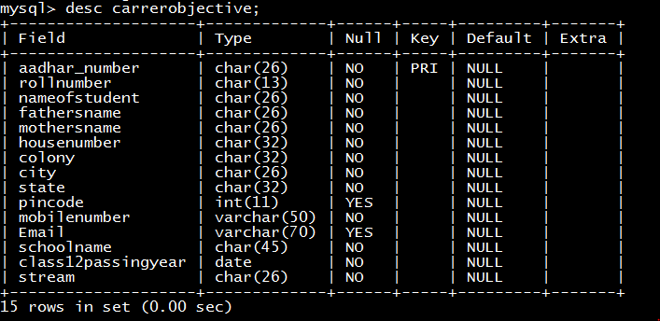
Table 2:- pcmcollege

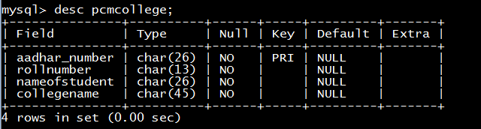
Table 3:- pcmcourse

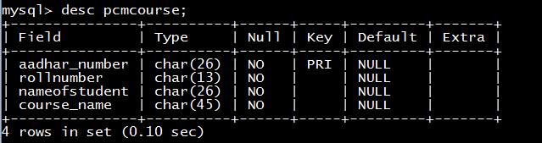
Table 4:- pcbcollege

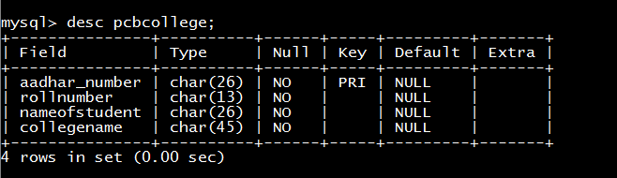
Table 5:- pcbcourse

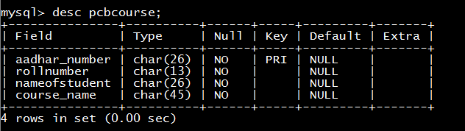
Table 6:- commerscollege

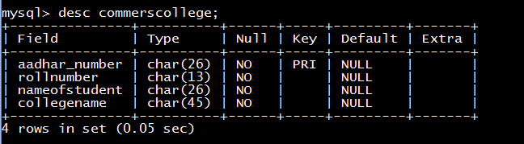
Table 7:- commerscourse

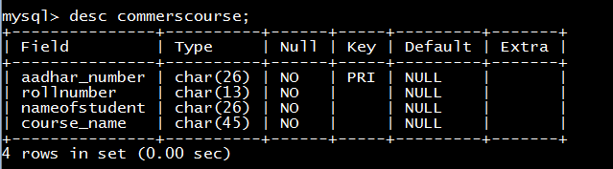

4.2 Menu Design:
Carrer Objective
this program is basically made for new up coming generation as the world is getting degitalised the compitative examination forms are also avilable online not as earlier that we get every form offline and just fill it and post it to the marked adderss, now a days we just visit a site or a link and click on it that perticulat link opens. As these days looking at the senario of up coming youths they are not capible of filling forms nither online nor offline they just need some support to do so , so this perticular program is trying to do so this part of program is trying to explain or trying to give the over view of form and how to fill it on a specfic site .this program is like a clone of online forms provied by the government of india it it the one succesive step towards the betterment of up coming youths

4.3 Event Coding:
Carrer Objective project(MAIN MODULE)
print("<","--"*25,"WELCOME","--"*25,">")
print("<","--"*27,"TO","--"*27,">")
print("<","--"*23,"CARRER OBJECTIVE","--"*22,">")
print("<","--"*25,"PROJECT","--"*26,">")
print("Enter your choice accordingly to the instructions given as do follow it")
while True:
print("\n\n\n\nPress 'Y' to continue else 'N' to quit")
cho=input("Enter your choice\n>>>").upper()
if cho=="Y":
print("Press the numbers alloted to functions to move on to next step!")
print("1)To Fill Form\n2)To Check the Details\n3)To Edit or to change the details in the form")
ch=int(input("Enter your choice here\n>>>"))
if ch==1:
import filling_form as ff
ff.fill_form()
pass
elif ch==2:
import view_form as vf
vf.view_of_form()
pass
elif ch==3:
import Edit_Details
pass
else:
print("Entered Wrong degit! Please Restart!")
continue
pass
elif cho=="N":
quit()
pass
else:
print("Wrong choice!!!!")
break

5. References
In order to work on this project titled Carrer Objective the following books and literature are refered by me during the various phases of development of the project.

(1) http://www.mysql.org/

(2) http://www.python.org/

(3) On-line Help of Python

(4) Informatics Practices for class XII _{-by Sumita Arora}
(5) Together with Informatics Practices
(6) Various Websites of Discussion Forum and software development activities.

Other than the above-mentioned books, the suggestions and supervision of my teacher and my class experience also helped me to develop this software project.

